SWITCH CASE:

TABLE:

CREATE TABLE EMPLYOEEID(EMPLOYEE_ID INT,EMPLOYEE_NAME VARCHAR(20), EMPLOYEE_DEPT VARCHAR(30),EMPLOYEE_QUALIFICATION CHAR(20));

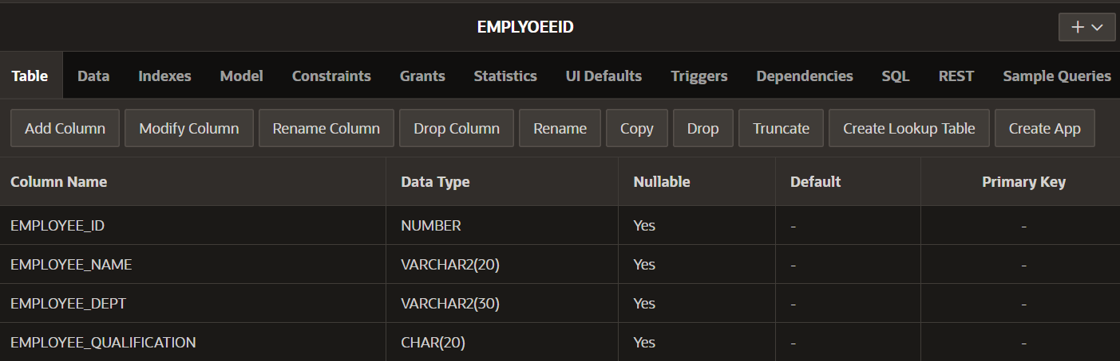

INSERT VALUES:

INSERT INTO EMPLYOEEID VALUES(90, 'SRINU', 'CHEMICAL', 'BTECH');

INSERT INTO EMPLYOEEID VALUES(80, 'RAMESH', 'COMPUTER', 'BTECH');

INSERT INTO EMPLYOEEID VALUES(70, 'NANI', 'MATHS', 'MASTERS');

INSERT INTO EMPLYOEEID VALUES(60, 'VENU', 'IT', 'BTECH');

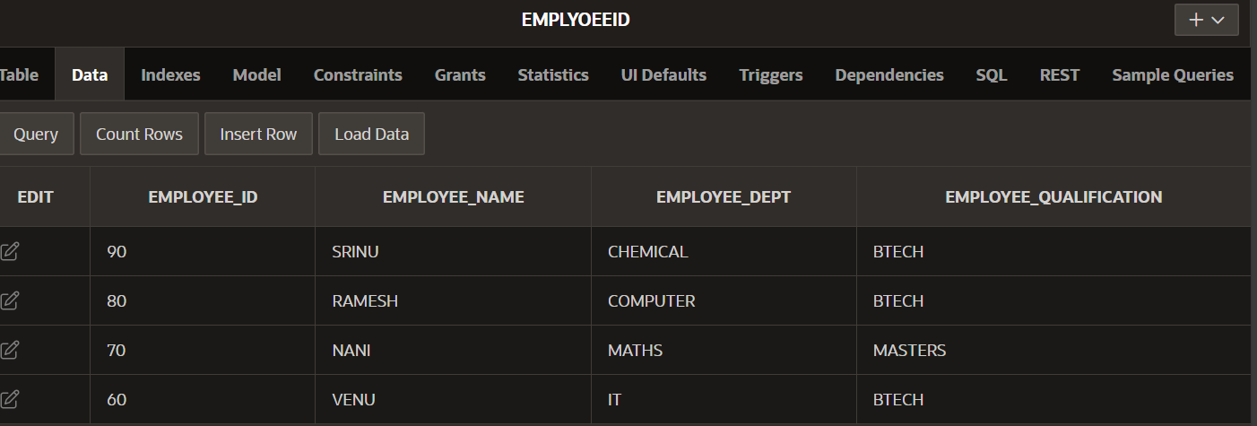

CASE CONDITION:

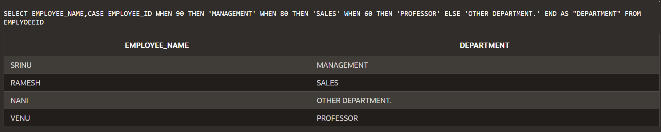

DECODE CONDITION:

